RAIZHELL ANN QUIJANO

IT 3301

**Exploration 01**

**Installation of GIT**

Visit the <https://git-scm.com/> for the installation

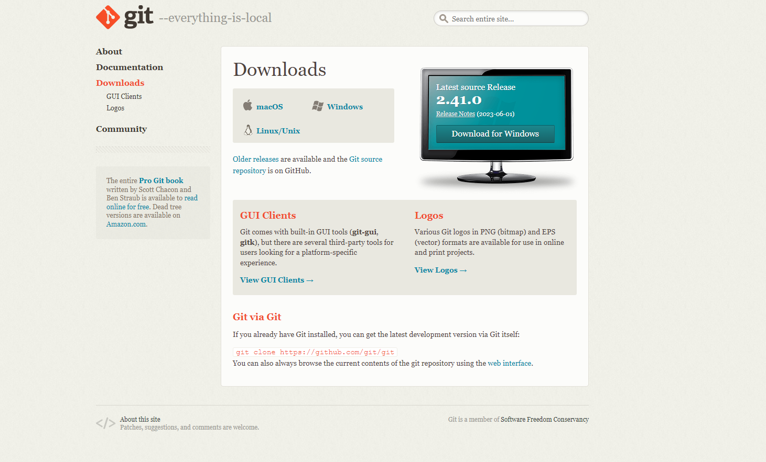

Download GIT

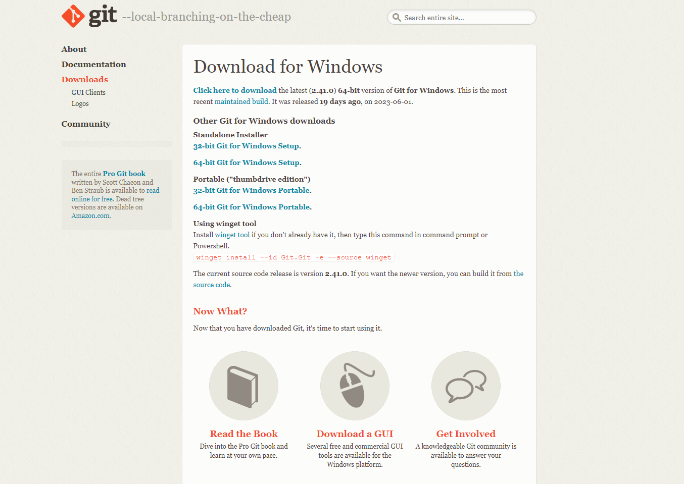

GIT Set-up

